

Diamond Report NEW

QAD EE 2016

Table of Contents
Objective 3
Process Steps 3
Select Customer or Supplier Schedule 3
Report Selections 3
Deselect Releases: 4
Emailing of the report: 4
Ready report in Excel in the mail box: 5

Objective

The objective of this document is to explain the process of using 7.5.7 *Customer & Supplier Diamond Report in QAD EE16

Process Steps

Select Customer or Supplier Schedule
In this field input either S (for supplier) or C (for Customer)
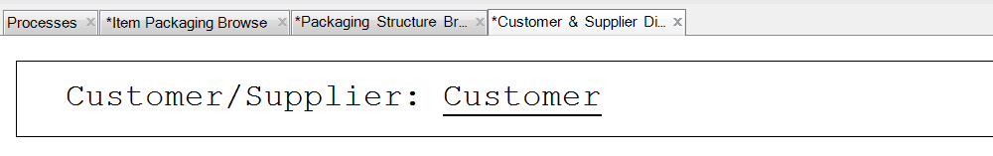
Then you will be able to input Customer or supplier ID in the relevant field:

Report Selections
In the table you will be able to see all the SO or PO for this Customer or Supplier. Choose one in selection field:
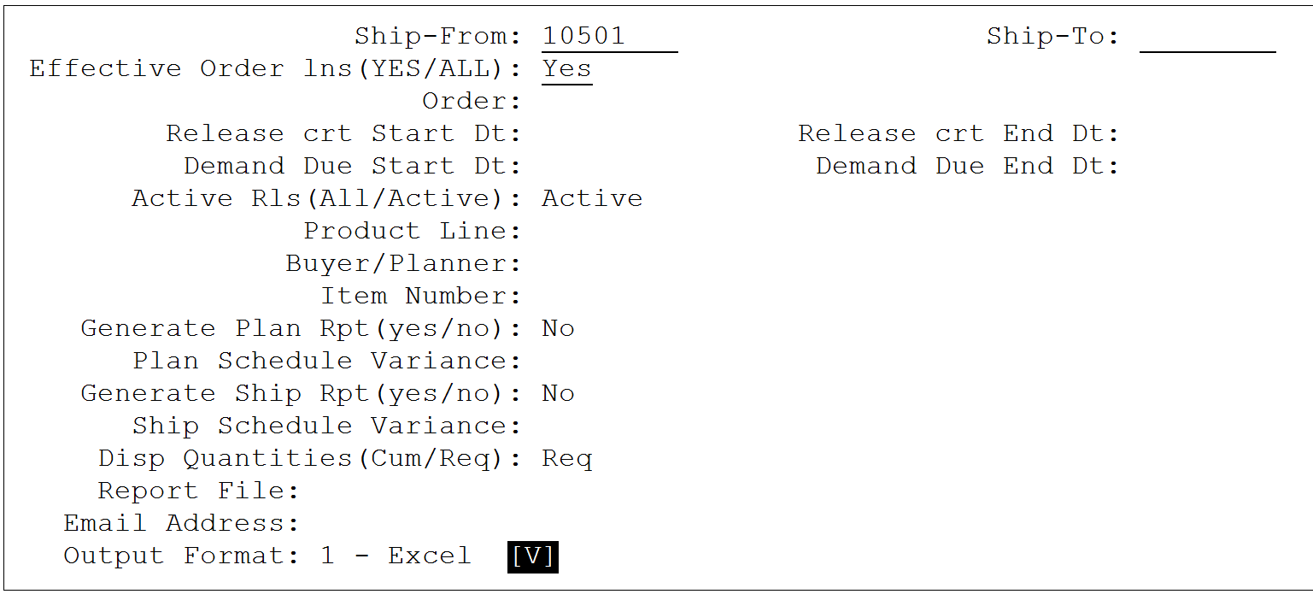

Important selections:
- Release Date: time frame when release was created
- Demand date : time frame for which demand is displayed
- Disp Quantities: if you want to see net (REQ) or cumulative (CUM) qty’s in your report.

Deselect Releases:

You have an option to deselect releases from the diamond. It is useful if you are getting release on daily basis and want to select only one release per week
Use Enter button to deselect releases from the output. Deselected releases are marked with star *:
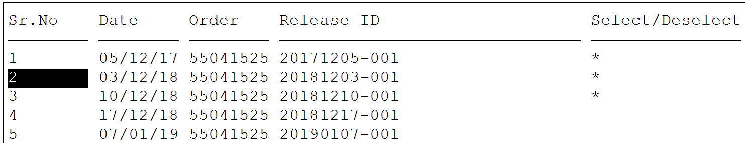
Exit this screen with F4 when finished.

Emailing of the report:

Verify that you saw this message at the end of the selection

Ready report in Excel in the mail box:
